Geometry: Unit 3, Lesson 9
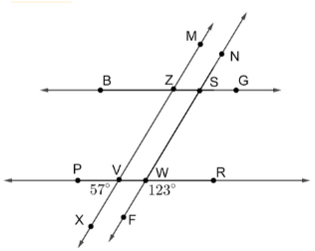
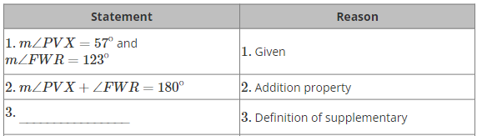
- An incomplete proof is shown. What is the reason that completes Step 3 of the proof?

Given: $\overset{⃡}{SM}∥\overset{⃡}{TN}$, $∠GFB≅∠BKG$
Prove: $\overset{⃡}{WP}∥\overset{⃡}{RH}$
$∠PVX$ and $∠FWR$ are supplementary
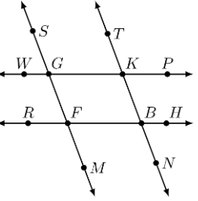
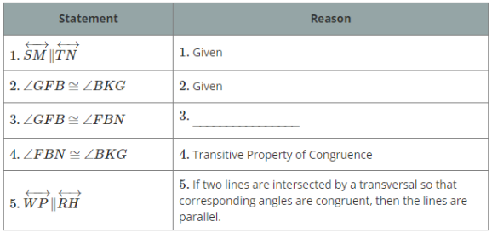
- An incomplete proof is shown. What is the reason that completes Step 3 of the proof?

Given: $\overset{⃡}{SM}∥\overset{⃡}{TN}$, $∠GFB≅∠BKG$
Prove: $\overset{⃡}{WP}∥\overset{⃡}{RH}$
If two parallel lines are intersected by a transversal, then the alternate interior angles are congruent.
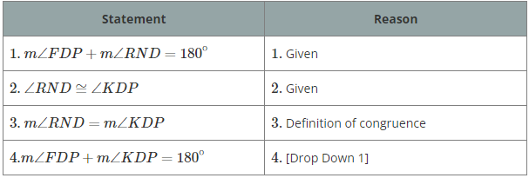
- An incomplete proof is shown. What is the reason that completes Step 4 of the proof?
Given: $m∠FDP+m∠RND=180°$, $∠RND≅∠KDP$
Prove: $m∠FDP+m∠KDP=180°$

Definition of congruence

